**PROBLEM SOLVING TASK-1**

**1.Iterate a number and find sum of it?**

**Source code:**

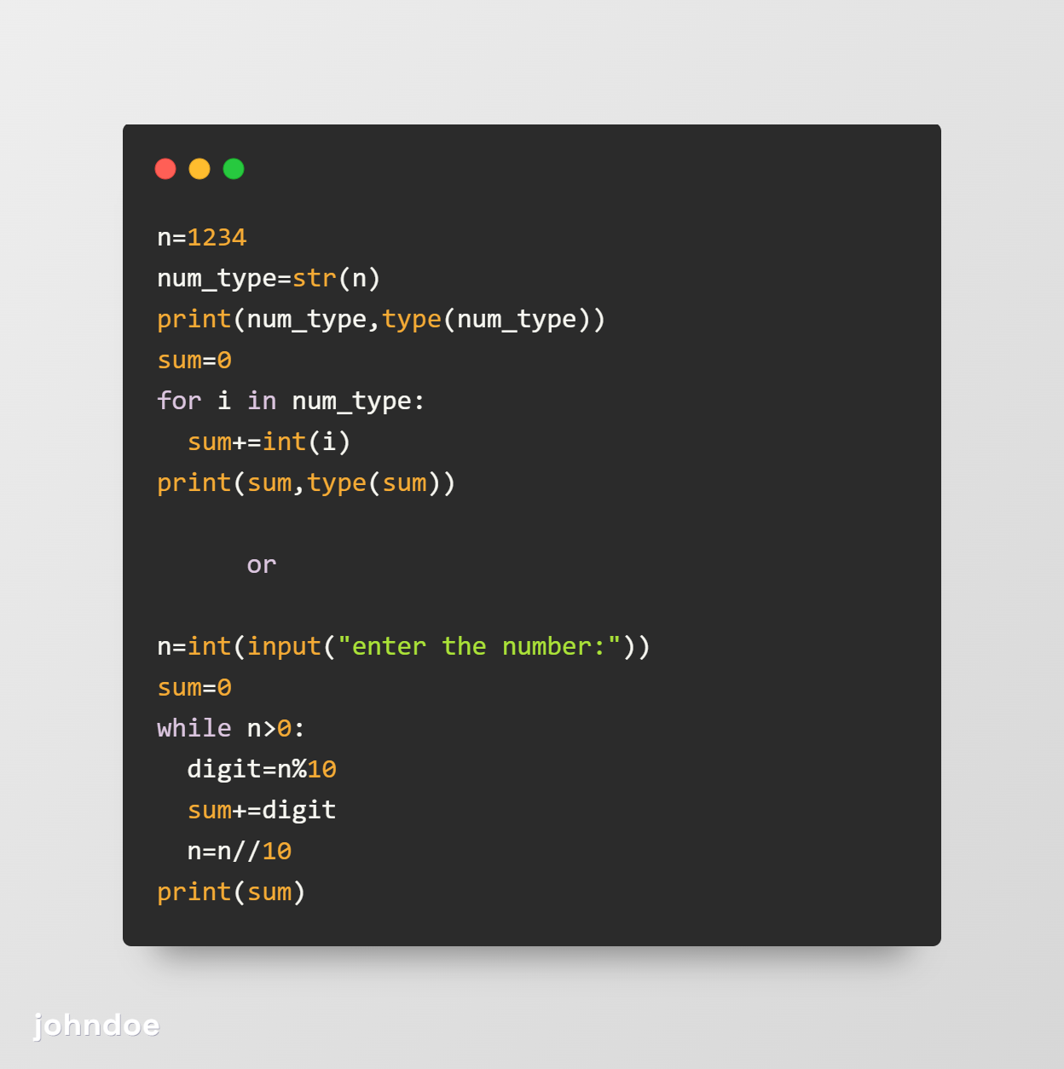

**2.Iterate a number and find number of digits in it?**

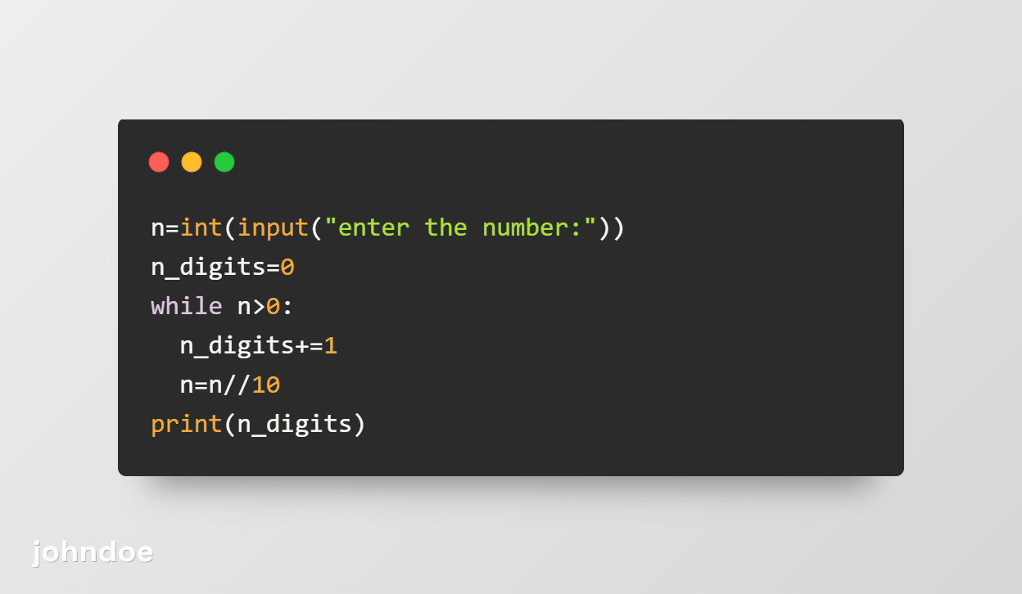

**3.Write a program to reverse the number?**

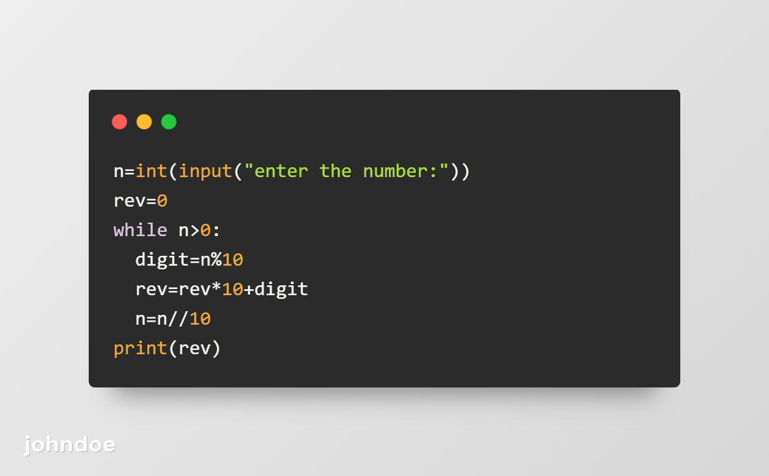

**4.Write a program to print sum of odd digits in number and even digits in number?**

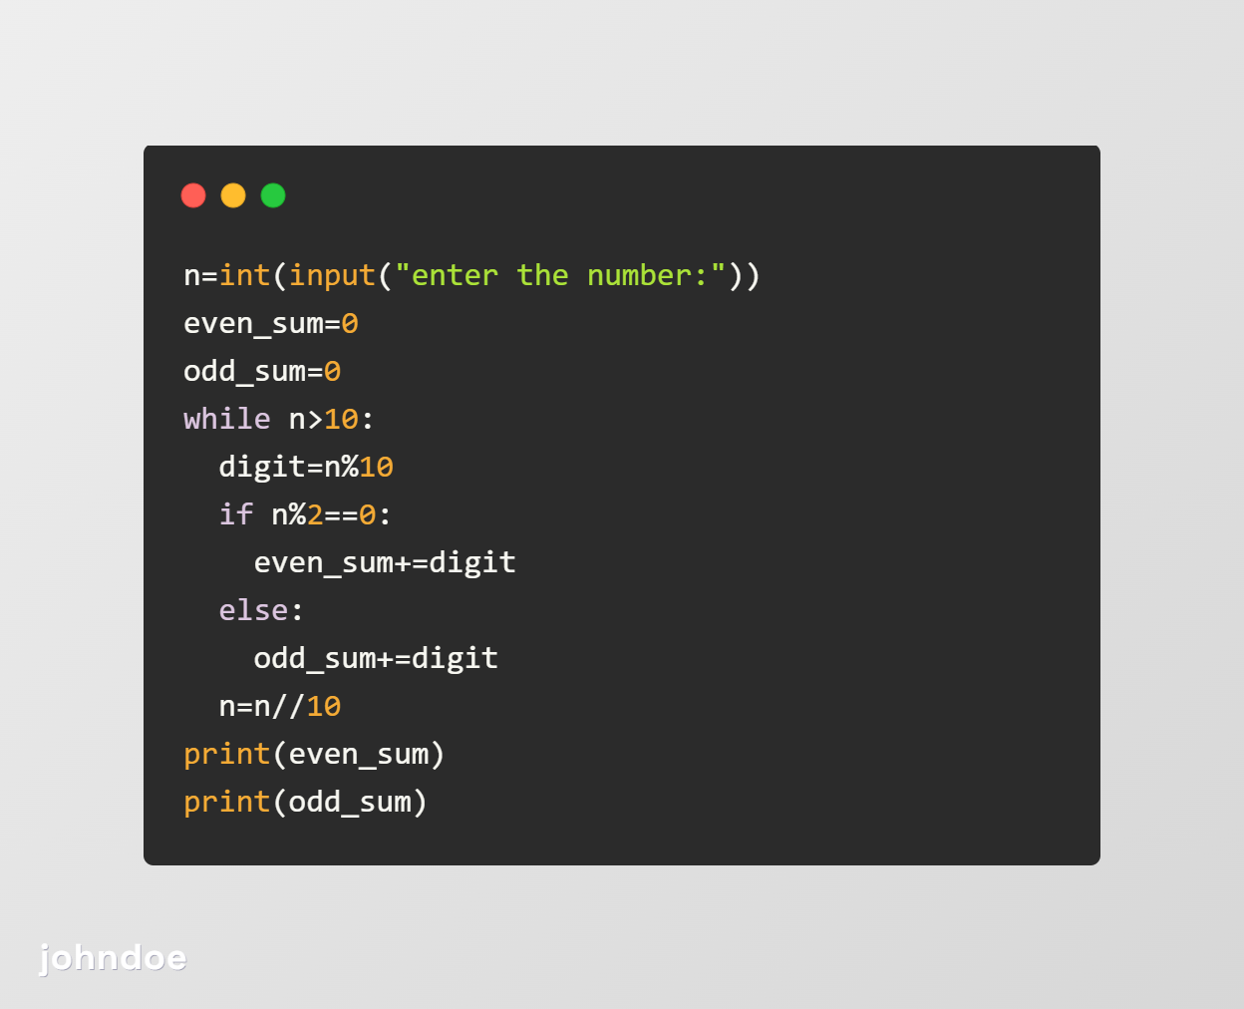

**5.Write a program to check number is prime or not?**

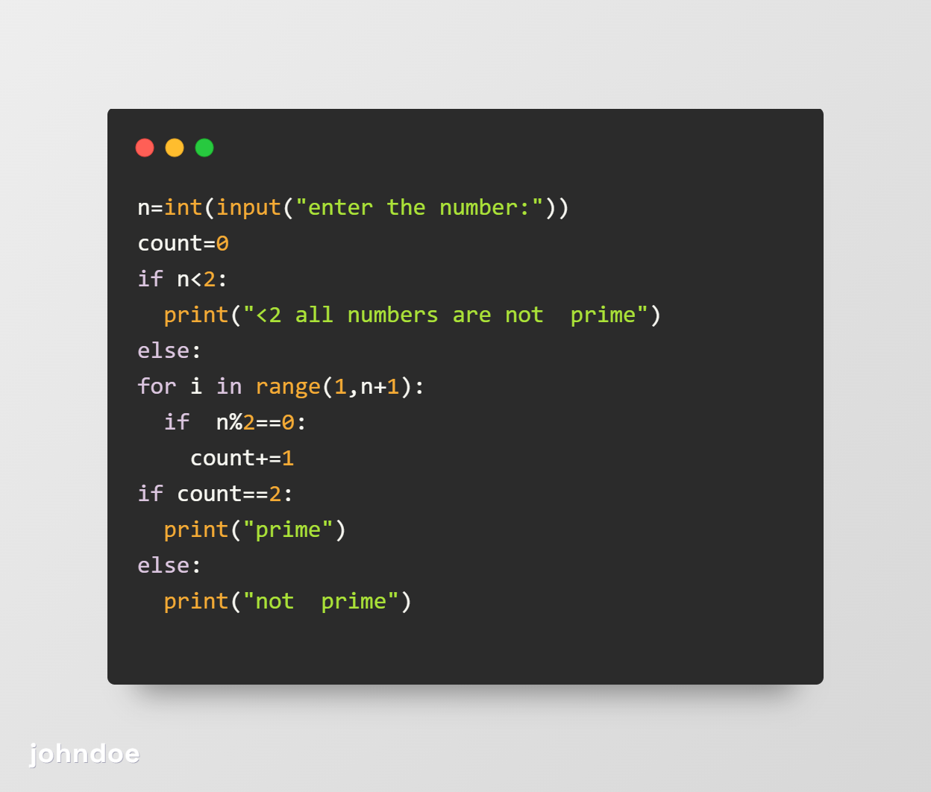

**6.Write a program to find numbers in certain range?**



**7.Write a program to find prime numbers in list? And create new list?**